**Dec. 23, 2020**

* Dbo.spDeleteNullRecords

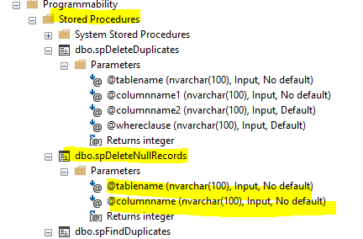

* Validate if Dbo.spDeleteNullRecords allows many arguments

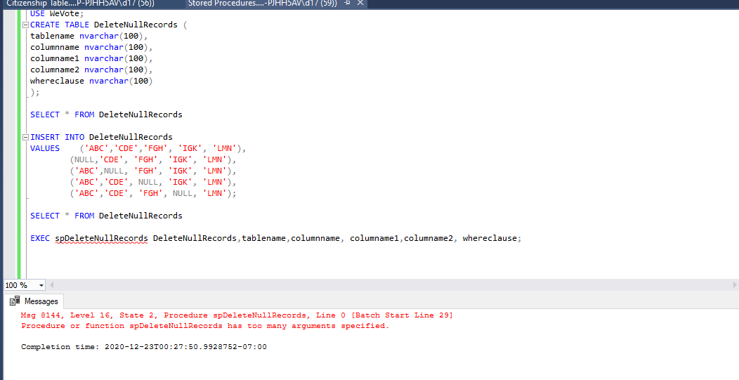

* 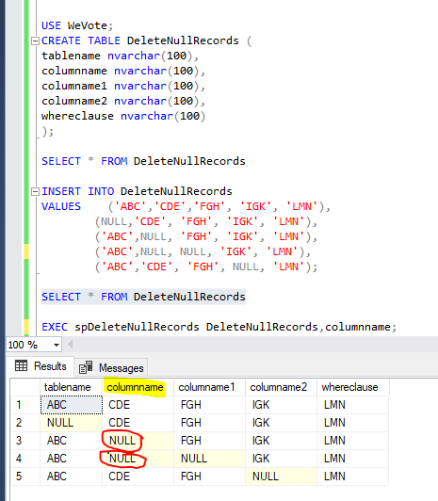Validate if Dbo.spDeleteNullRecords deletes NULL Record

